SU TECH
ELSEWEDY UNIVERSITY OF TECHNOLOGY – POLYTECHNIC OF EGYPT
Faculty of Engineering Technology

Social Media Forensics & OSINT Investigation

Hagar Maher Sabry
Rania Hesham Soliman
Eman Hesham Soliman

- Overview

This project is a Python-based OSINT tool focused on GitHub identity and relationship analysis. Given a list of GitHub usernames, it:

- Collects public GitHub profile and repository metadata.
- Builds relationships between the investigated users (location, follows, and real repo collaboration evidence).
- Builds a network graph, computes SNA metrics, and exports a graph image.
- Computes a risk score per user.
- Stores snapshots of repos over time and detects repo list changes.
- Checks for Wayback Machine snapshots and infers “deleted/missing” repos from local history.

- Inputs / Outputs

Inputs
- Usernames: comma separated.
fatma230103456 , RaniaHesham , Eman-SUT , hagarsabry230105968
Outputs
- JSON Report: osint_report.json
- profiles, relationships, graph stats, SNA metrics, risk scores, recovery findings
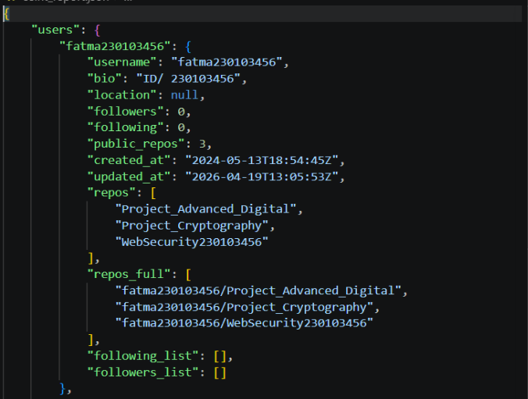

- Graph Image: network_graph.png
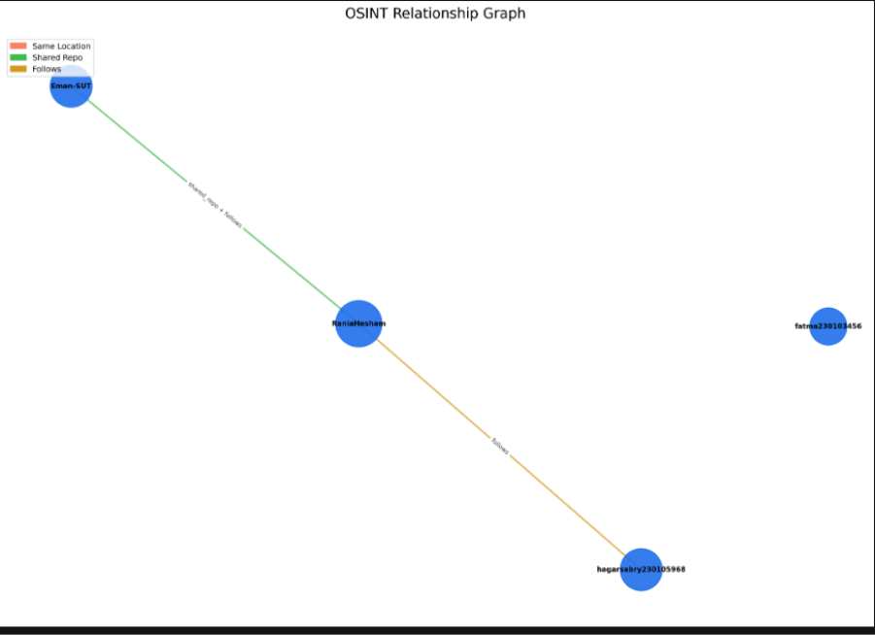

- Local Snapshot Cache: cache.json (repo snapshot history per user)
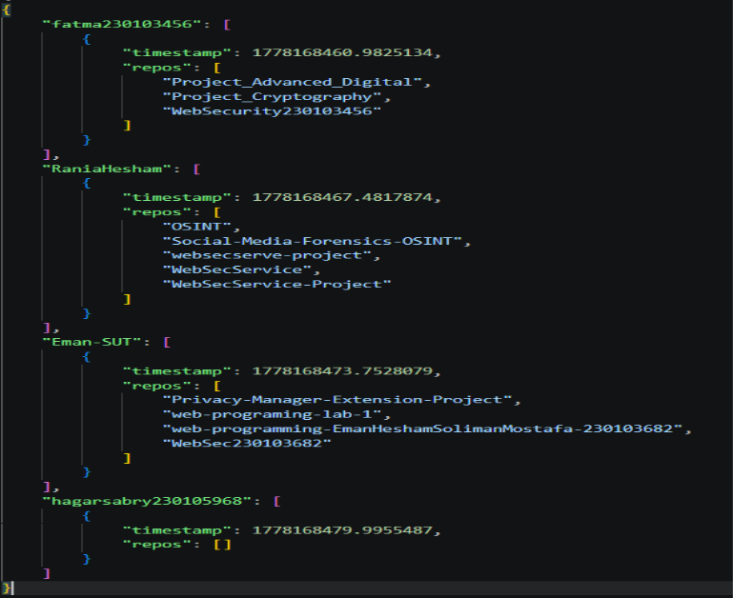
3) High-Level Architecture (Modules)
- main.py
- Orchestrates the full pipeline: collection → relationships → graph → metrics → risk → recovery → reporting.
- github_api.py
- GitHub data collection via REST API.
- Snapshot write/read logic (cache).
- Cross-platform checks (APIs + Sherlock CLI).
- Repo contributors lookup for “real shared repo” evidence.
- relationship_engine.py
- Computes edges between investigated users based on evidence signals.
- graph_engine.py
- Builds the networkx graph, computes communities and SNA metrics, renders PNG.
- risk_engine.py
- Computes per-user risk score (0–100) using identity, activity, cross-platform, and graph influence signals.
- recovery.py
- Wayback snapshot lookup.
- Deleted repo inference using cache history vs current repos (with normalization to reduce false positives).
4) Data Collection Details
GitHub API Endpoints Used
- User profile: GET /users/{username}
- User repos: GET /users/{username}/repos?per_page=100
- Following: GET /users/{username}/following?per_page=100
- Followers: GET /users/{username}/followers?per_page=100
- Repo contributors (collaboration evidence): GET /repos/{owner}/{repo}/contributors?per_page=100&anon=false

Profile Fields Extracted
For each user:
- Identity fields: login, bio, location
- Social counts: followers, following
- Activity fields: public_repos, created_at, updated_at
- Lists:
- repos (repo names)
- repos_full (owner/repo full_name list)
- followers_list, following_list

5) Snapshotting & Change Detection
Snapshot Storage (cache.json)
On each run per user:
- Store { timestamp, repos[] } for repo list snapshot.

Change Detection Logic
Compare the last two snapshots for a user:
- added: repos present now but not before
- deleted: repos present before but not now

Deleted Repo False-Positive Mitigation
Because older snapshots may store owner/repo while current lists may be only repo, the comparison normalizes:
- owner/repo → also counted as repo name
- Deleted logic avoids marking a repo deleted if its name is still present.
Additionally:
- If current_repos is empty (API error/rate limit), deleted detection returns [] to avoid “everything deleted”.

6) Relationship Detection (Edge Creation)
For each pair of investigated users (u1, u2):
A) Same Location
- Condition: both have non-empty location strings and they match case-insensitively.
- Reason label: same_location

B) Follows
- Condition: u1 follows u2 OR u2 follows u1
- Source: following lists from GitHub API
- Reason label: follows

C) Real Shared Repo (Collaboration Evidence)
- This is not “same repo name”.
- Condition:
- u2 appears in the contributor list of any repo in u1’s repos_full, OR
- u1 appears in the contributor list of any repo in u2’s repos_full
- Reason label: shared_repo
- Optimization:
- Contributor calls are cached in-memory.
- Repos per user checked are capped (default 20) to limit API calls.

Relationship Output Schema
Each relationship record:
- from, to
- score (weighted evidence)
- reasons (list of evidence labels)

7) Graph Model & Visualization
Graph Construction
- Graph type: undirected networkx.Graph
- Nodes: investigated usernames
- Edges: relationships from relationship_engine
- Edge attribute:
- reason: string built from reasons list (joined)

Visualization
- Layout: Kamada–Kawai
- Nodes:
- size scales with degree
- uniform node color
- Edges:
- color-coded by relationship reason (same_location, shared_repo, follows)
- Labels:
- node labels shown
- edge labels shown with reason
- Output: report/network_graph.png
Note: Synthetic investigated_together edges have been removed; if no relationships exist, the graph will contain nodes with zero edges.
8) Social Network Analysis (SNA)
Computed with NetworkX:
- Degree centrality
- Betweenness centrality
- Closeness centrality
- PageRank
Community detection:
- Greedy modularity communities
- Reported as count of communities
9) Risk Scoring
risk_engine.compute_risk() computes a 0–100 score per user using:
- Identity completeness: followers and repo count relative to others + missing bio signal
- Social ratio: followers vs following
- Cross-platform presence: fewer detected accounts increases risk
- Activity volatility: number of added/deleted repos between snapshots
- Network influence: degree/betweenness/pagerank reduces score slightly

10) Cross-Platform Checks
- API-based existence checks:
- GitHub, GitLab, Bitbucket
- Sherlock-based discovery:
- Instagram, Twitter, Facebook Result per platform:
- URL + boolean exists

11) Wayback Recovery
- Wayback availability API used to obtain “closest” archived snapshot URL for the GitHub profile page.
- Repo recovery inference uses snapshot history vs current repos (not definitive proof of deletion).

12) Operational Notes / Limitations
- GitHub API rate limits can affect completeness; use GITHUB_TOKEN for stability.
- Contributor-based collaboration detection depends on:
- public repos
- GitHub contributors endpoint availability (may be incomplete for some repos)
- Snapshot-based “deleted repos” is an inference from local history; renamed/transferred/private repos can appear “deleted” depending on visibility and stored identifiers.
- Repo pagination is limited to 100 per call; very large accounts may require pagination support for full coverage.
13) Run Instructions (Windows)
- Install dependencies (typical):
- requests, networkx, matplotlib, bs4
- set token:
- Run:
- python main.py
- Enter usernames (comma-separated) when prompted.
- Collect outputs:
- osint_report.json
- network_graph.png
14) Report Artifacts
The final JSON report includes:
- users: profiles per username
- relationships: edges with reasons and score
- risk_scores: per user
- graph: node/edge counts + community count
- metrics: SNA results
- recovery: wayback snapshots count + deleted repo

THANK YOU

Supervised by
Dr. Ayman Taha
TA. Maryam Adel



